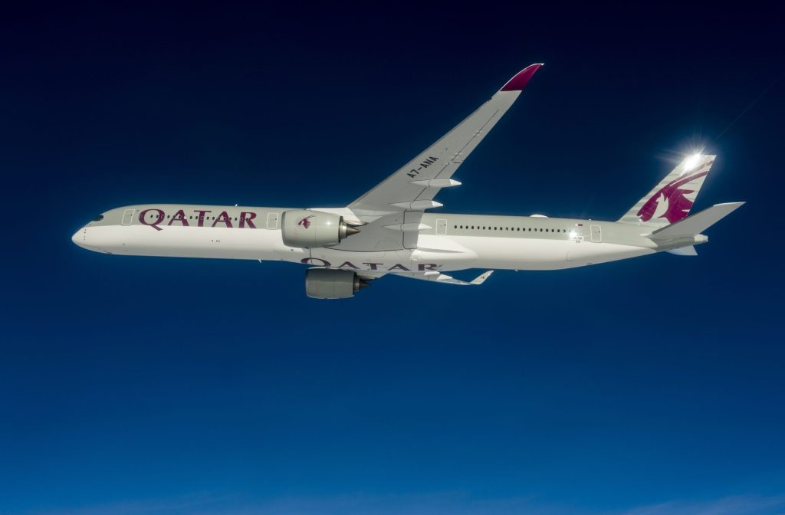

Dear Trade Partner,
We would like to share an update that we will operate a limited number of flights between 18 – 28 March 2026. You can book your clients on these flights. These schedules have been enhanced to give your clients more flexibility who wish to travel.
Please note availability remains constrained and is subject to change. We recommend checking the latest flight status regularly and securing bookings as soon as possible.

  Origin
  LHR
  LHR
  LHR
  LHR
  LHR
  LHR
  LHR
  LHR
  LHR
  LHR
  MAN
  MAN
  MAN
  MAN
  MAN
  MAN
  MAN
  MAN
  MAN
  MAN
  BHX
  BHX
  BHX
  BHX
  BHX
  BHX
  BHX
  BHX
  BHX
  BHX
  DUB
  DUB
  DUB
  DUB
  Destination
  BKK
  CMB
  DAC
  HAN
  HKT
  ISB
  KHI
  KTM
  LHE
  MNL
  BKK
  CMB
  COK
  HKT
  ISB
  JED
  KTM
  KUL
  LHE
  PER
  ATQ
  BKK
  CMB
  DEL
  HKT
  ISB
  KHI
  KTM
  KUL
  LHE
  LHE
  ISB
  COK
  MNL

Your patience and understanding mean a great deal to us, and we are truly grateful for your continued support at this challenging time.

﻿Regards
Qatar Airways

The following conditions apply during the booking process.
- Minimum connecting time: 75 minutes
- Maximum transit time in Doha: 6 hours
- STPC: Not available during this period (Availability subject to change and will be updated every 24h)
We have an enhanced page on our trade portal that will you the information you need when travel plans change for your client.
Please note: Flight schedules are subject to change or cancellation due to operational, regulatory, safety or other circumstances beyond our control





